**ls command:-**

ls command is used to list the files in that current working directory.

For example,

In the below screenshot, ls command lists the files that is present in **Student** folder such as **“Intro”** and **“student”**

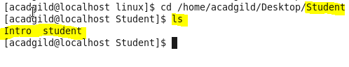

Please refer the below screenshot.

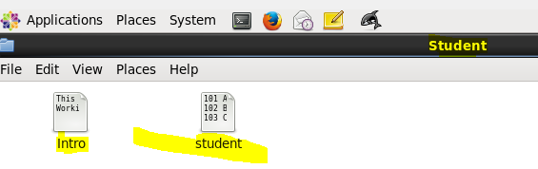

**ls –l:-**

-l option under ls command displays the total directory size, modified date or time for each file in that directory.

